ASSESSMENT TOOL 1

COURSE NAME: MOBILE COMPUTING
COURSE CODE: ITA03

COURSE OUTCOME COVERED

CO2: Compare mobile communication technologies, including multiple access techniques and network evolution, based on performance and applications. (BL-1, BL-2, BL-3)

QUESTIONS: 100 Total Marks: 100

Annexure A

MCQ

Code of Conduct:

I ANIKSHA EVANJALIN M(192521308) (Name / Reg No) certify that this submission is my original work and that I have adhered to the guidelines specified for this assessment.

I understand that any violation of academic integrity rules will result in disciplinary action.

Signature of the student:
ANIKSHA EVANJALIN M

Annexure A - QUESTIONS

1. A network engineer is designing a new cellular system for a densely populated urban area. The primary challenge is the extremely high user density, leading to significant co-channel interference. To maximize spectral efficiency and user capacity, the engineer decides to implement a multiple access scheme that allows multiple users to share the same frequency channel at the same time by separating them based on their unique spatial signatures. This technique requires advanced antenna arrays and signal processing to steer beams towards specific users. Which of the following multiple access techniques is the engineer primarily employing?
a) Time Division Multiple Access (TDMA)
b) Code Division Multiple Access (CDMA)
c) Space Division Multiple Access (SDMA)
d) Frequency Division Multiple Access (FDMA)
2. A telecommunications analyst is comparing the fundamental differences between mobile communication and mobile computing. While mobile communication focuses on the transmission of voice and data over wireless networks, mobile computing encompasses a broader scope. An executive argues that the primary distinction lies in the device's capability to process data locally rather than just relaying it. Considering the core definitions and evolution of these fields, which of the following scenarios best illustrates the shift from a pure mobile communication paradigm to a mobile computing paradigm?
a) A GSM handset authenticating with the network using a SIM card.
b) A legacy pager receiving a one-way text message.
c) A smartphone running a navigation app that processes GPS data locally to provide real-time traffic updates.
d) A traditional cellular phone making a circuit-switched voice call to a landline.
3. A radio network planner is evaluating the performance of different duplexing methods. In Frequency Division Duplexing (FDD), uplink and downlink transmissions occur on separate frequency bands, requiring a guard band to prevent interference. In Time Division Duplexing (TDD), both transmissions occur on the same frequency band but in different time slots. The planner is tasked with deploying a system in a region with highly asymmetric traffic patterns, where the downlink data demand (e.g., video streaming) far exceeds the uplink demand. Which of the following is the most significant advantage of TDD over FDD in this specific scenario?
a) TDD requires simpler and less expensive RF filters.
b) TDD allows for dynamic allocation of time slots to better match the asymmetric traffic load.
c) TDD provides better coverage for a given transmit power.
d) TDD is less susceptible to multipath fading.
4. An engineer is analyzing the capacity of a cellular system that uses an FDMA scheme. The total available bandwidth is 25 MHz, and each voice channel requires a bandwidth of 25 kHz, including guard bands. The engineer calculates the total number of available channels. However, to reduce co-channel interference, the network employs a frequency reuse factor of 1/7, meaning the available channels are divided among 7 cells in a cluster. What is the total number of voice channels available per cell in this specific system configuration?
a) 142.85 channels (approximately 143)
b) 7000 channels
c) 1000 channels
d) 25 channels
5. A network designer is choosing between TDMA and FDMA for a new satellite communication system. The designer is concerned about the non-linear effects of the High-Power Amplifier (HPA) on the satellite transponder. In FDMA, multiple carriers are amplified simultaneously, which forces the HPA to operate in a back-off region to avoid intermodulation distortion, thus reducing its efficiency. In TDMA, only one carrier uses the transponder at a time, allowing the HPA to operate at or near saturation. Considering this, what is the primary advantage of choosing TDMA over FDMA in this context?
a) TDMA provides a lower delay in data transmission.
b) TDMA allows for simpler synchronization between the earth station and the satellite.
c) TDMA eliminates the need for a guard band between channels.
d) TDMA allows the satellite's power amplifier to operate more efficiently with less intermodulation distortion.
6. A research team is developing a new wireless standard for the Internet of Things (IoT) where many devices need to transmit small amounts of data sporadically. The team is considering CDMA as a potential access method. One of the key challenges in a CDMA system is the "near-far" problem, where a nearby high-power transmitter can drown out the signal from a distant low- power transmitter. To mitigate this, the system employs a sophisticated power control mechanism. What is the primary objective of this power control mechanism in a CDMA system?
a) To ensure that all mobile devices transmit at their maximum power.
b) To ensure that the signal from each user arrives at the base station with the same power level.
c) To allocate different frequency bands to mobile devices based on their distance from the base station.
d) To reduce the battery consumption of mobile devices.
7. A telecommunications historian is documenting the evolution of mobile networks from 1G to 5G. They note that each generation introduced significant technological leaps. The transition from 1G (analog) to 2G (digital) was revolutionary, primarily due to the introduction of digital modulation and multiple access techniques. Which of the following was the most significant advantage of 2G systems like GSM over 1G systems like AMPS, fundamentally changing the way cellular networks operated and enabling future data services?
a) The use of circuit-switched technology for voice calls.
b) The introduction of Frequency Division Duplexing (FDD).
c) The introduction of digital encryption and support for SMS and data services.
d) The use of a cellular architecture with handover capabilities.
8. A network operator is upgrading its 3G UMTS network to support higher data rates. They are considering the implementation of High-Speed Downlink Packet Access (HSDPA). HSDPA introduces several new features to the UMTS air interface, including Adaptive Modulation and Coding (AMC) and fast scheduling. AMC allows the system to dynamically change the modulation scheme (e.g., QPSK, 16-QAM) and coding rate based on the channel quality reported by the mobile device. What is the primary benefit of using AMC in HSDPA?
a) It simplifies the design of the mobile receiver.
b) It allows the network to adapt to varying radio conditions, optimizing throughput for each user.
c) It reduces the need for handovers between cells.
d) It increases the coverage area of each cell.
9. A mobile network operator is analyzing the performance of its GSM network. A subscriber is traveling from a city center to a suburb, crossing several cell boundaries. The network must ensure the call is not dropped. The process involves the Mobile Switching Center (MSC), Base Station Controllers (BSCs), and Base Transceiver Stations (BTSs). In GSM, there are two main types of handover: intra-BSC and inter-BSC (which may be intra-MSC or inter-MSC). The subscriber is currently in a call, connected to a BTS managed by BSC-1, and is moving towards an area served by BTS-2, which is managed by BSC-2. Both BSCs are connected to the same MSC. Which sequence of events correctly describes the network elements involved in performing this handover?
a) BSC-1 informs MSC of the need for a handover, MSC coordinates with BSC-2, and then instructs BSC-1 to execute the handover.
b) The MS initiates the handover and communicates directly with the new BTS to establish a connection.
c) BSC-1 makes the handover decision and controls the entire process, informing the MS to switch to BSC-2's frequency.
d) The MSC bypasses the BSCs and directly controls the handover between the two BTSs.
10. A network engineer is configuring the location update procedure for a GSM network. The network is divided into several Location Areas (LAs), each identified by a Location Area Identity (LAI). When a mobile subscriber (MS) moves from one LA to another, it must perform a Location Update to inform the network of its new location. However, the MS also performs a periodic location update even if it hasn't moved to a new LA. What is the primary purpose of this periodic location update, and what network element stores the subscriber's current LAI?
a) To update the MS's service subscription; stored in the HLR.
b) To update the MS's battery status; stored in the BSC.
c) To confirm the MS's identity; stored in the EIR.
d) To ensure the network is aware of the MS's availability and location in case of a power-off or out-of-coverage event; stored in the VLR.
11. A systems analyst is comparing the architectural differences between GSM and GPRS. GSM is fundamentally a circuit-switched network designed for voice, while GPRS is a packet-switched overlay network designed for data. An engineer argues that GPRS is more efficient for bursty data applications because it does not permanently dedicate resources for a single user. The analyst counters by pointing out a significant architectural addition in GPRS. Which of the following is the core network element introduced in GPRS that is responsible for routing and forwarding data packets to and from the mobile users, essentially acting as a gateway to external packet data networks like the Internet?
a) Serving GPRS Support Node (SGSN) and Gateway GPRS Support Node (GGSN)
b) Base Station Controller (BSC)
c) Home Location Register (HLR)
d) Mobile Switching Center (MSC)
12. A technician is studying different standards used in mobile communications. They come across the Digital Enhanced Cordless Telecommunications (DECT) standard. DECT is widely used for cordless phones and wireless office systems. The technician notes that unlike GSM or UMTS, which are designed for wide-area coverage, DECT is designed for short-range, low-mobility applications. Considering its key characteristics and applications, which of the following statements accurately differentiates DECT from a typical cellular network standard like GSM?
a) DECT operates in a licensed spectrum band, whereas GSM operates in an unlicensed band.
b) DECT is a packet-switched technology only, while GSM is circuit-switched only.
c) DECT primarily uses a Time Division Multiple Access (TDMA) scheme with a fixed frame structure for cordless telephony.
d) DECT supports high-speed vehicular handover, unlike GSM which is only for pedestrian users.
13. A network designer is evaluating the security protocols in different generations of mobile networks. One of the primary security goals is to prevent a rogue base station from impersonating a legitimate network and tricking a mobile device into connecting to it. In GSM, the network authenticates the mobile device, but the mobile device does not authenticate the network. This vulnerability was addressed in UMTS with a mutual authentication procedure. What mechanism in UMTS enables the mobile device to authenticate the network, thereby mitigating the "false base station" attack?
a) The use of Frequency Division Duplexing (FDD) for the air interface.
b) The introduction of the Authentication Token (AUTN) in the authentication process.
c) The use of a longer Temporary Mobile Subscriber Identity (TMSI).
d) The use of a stronger encryption algorithm (A5/3).
14. A mobile network operator is planning its transition from 4G LTE to 5G NR (New Radio). One of the key differences between the two is the approach to the core network architecture. The 5G core network is designed to be service-based and more flexible, supporting network slicing. Which of the following concepts is central to the 5G core network architecture and is a significant departure from the Evolved Packet Core (EPC) used in LTE?
a) A service-based architecture (SBA) where network functions communicate via standardized service-based interfaces.
b) A dedicated hardware-based approach for all network functions.
c) A single, monolithic Mobility Management Entity (MME).
d) The continued use of circuit-switched fallback (CSFB) for voice calls.
15. An engineer is analyzing the performance of OFDMA compared to CDMA for a 4G LTE system. The engineer notes that both schemes allow multiple users to access the network simultaneously. However, OFDMA, by using a large number of orthogonal subcarriers, is inherently more robust against a specific type of interference that severely degrades CDMA performance, especially in high-data-rate scenarios. This interference arises from signals taking multiple paths to the receiver. What is this phenomenon, and how does OFDMA's architecture inherently provide resilience against it?
a) Near-far effect; mitigated by using a higher chip rate.
b) Co-channel interference; mitigated by frequency hopping.
c) Adjacent channel interference; mitigated by using guard bands between subcarriers.
d) Multipath fading; mitigated by using a cyclic prefix and long symbol duration.
16. A student is preparing a presentation on the evolution of cellular networks, specifically comparing the key performance indicators of 1G through 5G. One slide focuses on the peak data rates. The student correctly notes that 1G had no data capability, 2G (GSM) introduced data at low speeds (9.6 kbps), 3G (UMTS) offered up to 2 Mbps, and 4G (LTE) offered hundreds of Mbps. However, the student is confused about the enhancements made to 3G to achieve higher data rates before 4G was introduced. Which of the following technologies was introduced in 3G (UMTS) to significantly increase downlink data rates, forming a bridge towards 4G?
a) Global System for Mobile communications (GSM)
b) High-Speed Downlink Packet Access (HSDPA)
c) High-Speed Circuit Switched Data (HSCSD)
d) General Packet Radio Service (GPRS)
17. A mobile device is communicating with a base station. In the context of radio interface protocols, the operation of the system is often described in terms of a layered architecture. The physical layer (Layer 1) is responsible for the actual transmission and reception of bits over the air. The data link layer (Layer 2) is responsible for providing a reliable link between the mobile station and the base station. One crucial function of the data link layer is the segmentation and reassembly of data, as well as error control. In GSM, which sub-layer of Layer 2 is specifically responsible for managing the logical link between the MS and the BSS, performing functions like error correction and flow control?
a) The Medium Access Control (MAC) layer
b) The Mobility Management (MM) layer
c) The Radio Link Control (RLC) layer
d) The Physical Layer (L1)
18. A wireless communication researcher is studying the localization techniques used in cellular networks. In GSM, location services can be based on different principles. Cell Identity (CI) is the simplest method, where the mobile's location is known to be within the coverage area of a particular cell. However, more accurate methods like Time of Arrival (TOA) and Time Difference of Arrival (TDOA) are also used. The researcher is analyzing a scenario where a mobile device transmits a signal, and three base stations measure the signal's arrival time. TDOA calculates the difference in arrival times at pairs of base stations. What is the fundamental principle used to determine the location in TDOA-based localization?
a) The mobile's location is determined by the angle of arrival (AOA) of the signal at each base station.
b) The mobile's location is the centroid of the three base stations.
c) The mobile's location is the intersection point of hyperbolas, which represent the difference in distance from the mobile to two base stations.
d) The mobile's location is the intersection point of three circles, each centered at a base station.
19. A network operator is planning a conference in a large convention center. To handle the anticipated high volume of mobile data traffic, they decide to install a small-cell system. They are debating between using a femtocell and a picocell. Both are types of small cells, but they serve different purposes. The convention center is a publicly accessible space with an expected traffic density of hundreds of users. Which of the following correctly describes the primary difference in the deployment scenario and capacity of a femtocell versus a picocell in this context?
a) A picocell is a public small cell covering a larger area (e.g., a convention center floor) and supporting more users than a residential femtocell.
b) Femtocells use licensed spectrum, whereas picocells use unlicensed spectrum like Wi-Fi.
c) Both femtocells and picocells have the same range and capacity; the difference is only in their backhaul connection.
d) A femtocell is typically used for large public spaces, while a picocell is designed for residential or small office use.
20. A systems engineer is analyzing the handover process in a GSM network, focusing on the role of the Mobile Station (MS). The MS continuously measures the signal strength and quality of the serving cell and its neighboring cells. These measurements are reported to the network. While the network largely controls the handover decision, the MS can initiate a specific type of handover. In GSM, what is this type of handover, and under what condition does it typically occur?
a) Handover initiated by the MS; this is a standard procedure known as "Mobile Assisted Handover" (MAHO).
b) Asynchronous handover; initiated to balance traffic load between cells.
c) Synchronous handover; initiated when the MS detects a stronger neighboring cell.
d) Emergency handover; initiated by the MS when the serving cell's signal quality drops below a critical threshold.
21. A university professor is explaining the concept of multiple access techniques to a class. The professor uses a metaphor: FDMA is like having separate radio stations on different frequencies; TDMA is like people taking turns talking in a conversation; CDMA is like a cocktail party where everyone speaks a different language and the listener can tune in to one specific language. Based on this metaphor, the professor asks the class to identify the key challenge of the CDMA system (the cocktail party). Which of the following best describes the "near-far" problem in CDMA in this context?
a) The challenge of understanding a language if too many people are speaking the same language.
b) The need to schedule a time for each person to speak.
c) The difficulty in hearing a quiet speaker who is far away when a loud speaker is very close to you, even though they are speaking different languages.
d) The problem of interference from overlapping frequencies in the radio spectrum.
22. An intern at a telecom company is trying to understand the circuit-switched and packet-switched cores in a GSM/GPRS network. The intern is confused about the path a data packet takes when a user is browsing the web. The user sends a request which goes from the mobile station to the base station and then to the BSC. The intern correctly identifies that for GPRS, the data then goes to the SGSN. What is the final network element that the packet traverses to exit the mobile operator's core network and reach the public internet?
a) The Base Station Controller (BSC)
b) The Mobile Switching Center (MSC)
c) The Gateway GPRS Support Node (GGSN)
d) The Home Location Register (HLR)
23. A wireless network analyst is comparing the characteristics of Code Division Multiple Access (CDMA) and Orthogonal Frequency Division Multiple Access (OFDMA). They note that while CDMA uses a spreading code to spread the signal over a wide bandwidth, OFDMA uses multiple orthogonal subcarriers. The analyst is evaluating the spectral efficiency of both in a multi-path environment. A major advantage of OFDMA over CDMA in this context is its resilience to frequency-selective fading. What is the fundamental reason for this increased resilience?
a) OFDMA divides the wideband channel into many narrowband subcarriers, each experiencing flat fading, making equalization simpler.
b) OFDMA is less susceptible to the near-far problem.
c) OFDMA does not require any power control.
d) OFDMA uses a higher chip rate than CDMA.
24. A network engineer is designing the security architecture for a new mobile network. The engineer wants to ensure mutual authentication between the mobile device and the network. They are studying the GSM and UMTS authentication mechanisms. In GSM, the network authenticates the user using a challenge-response mechanism based on the Ki key on the SIM. However, UMTS introduced a more robust mechanism to also authenticate the network. What is the key difference that allows the UMTS mobile station (USIM) to validate the network's authenticity?
a) UMTS requires the user to enter a PIN for every authentication event.
b) UMTS uses a new ciphering algorithm (A5/1).
c) UMTS uses a longer encryption key (Kc).
d) UMTS includes an Authentication Token (AUTN) in the challenge, allowing the MS to verify the network's identity.
25. A telecommunications operator is planning a new network deployment. They are considering using High-Speed Circuit Switched Data (HSCSD) to offer data services. HSCSD is an enhancement of GSM that allows a single mobile station to use multiple time slots simultaneously. An engineer argues that HSCSD is inefficient compared to GPRS. What is the core architectural disadvantage of HSCSD that leads to this inefficiency for typical data traffic?
a) HSCSD has a higher latency than GPRS.
b) HSCSD, being a circuit-switched technology, reserves resources (time slots) for the duration of the connection, regardless of whether data is being transmitted.
c) HSCSD is not compatible with existing GSM infrastructure.
d) HSCSD uses a less efficient modulation scheme than GPRS.
26. A radio planner is calculating the capacity of an FDMA system. The system has a total bandwidth of 12.5 MHz. Each channel requires 30 kHz of bandwidth. The system uses a 4-cell reuse pattern (N=4). What is the total number of channels available per cell if the operator wants to maximize capacity while adhering to the reuse pattern?
a) 104.17 (approx. 104) channels
b) 416.67 (approx. 417) channels
c) 1666.67 (approx. 1667) channels
d) 30 channels
27. A mobile subscriber is driving on a highway and is using a GSM phone for a voice call. The call is handed over from one cell to another. The handover process involves several signaling messages between the mobile station (MS) and the network. Which of the following best describes the primary purpose of the "Handover Command" message sent from the network to the MS?
a) To instruct the MS on which new frequency and time slot to use for the connection.
b) To request the MS to measure the signal quality of the new cell.
c) To confirm that the MS has successfully disconnected from the old cell.
d) To inform the MS that the network has dropped the call due to an error.
28. An engineer is comparing the power control mechanisms of CDMA and GSM. In GSM, power control is relatively slow and is mainly used to reduce interference and save battery power. In CDMA, power control is fast and stringent. Why is fast and accurate power control so critical for the proper operation of a CDMA system?
a) To prevent the mobile station's battery from draining too quickly.
b) To ensure that each mobile station's signal arrives at the base station with the same power level, thereby maximizing the system capacity.
c) To reduce the frequency of handovers between cells.
d) To allow the system to use a lower chip rate.
29. A researcher is evaluating the performance of OFDMA in an LTE system. The researcher notes that OFDMA uses a Cyclic Prefix (CP) to mitigate Inter-Symbol Interference (ISI). The CP is a copy of the end of the symbol appended to the beginning. However, the CP consumes a portion of the available bandwidth and power. An engineer argues that for a high-data-rate system in a highly dispersive (large multipath delay spread) environment, a longer CP is necessary. What is the primary trade- off in choosing the length of the Cyclic Prefix?
a) A longer CP increases data rate but reduces coverage.
b) A longer CP reduces Peak-to-Average Power Ratio (PAPR) but increases latency.
c) A longer CP mitigates ISI more effectively but reduces spectral efficiency.
d) A longer CP simplifies the receiver design but increases the battery drain on the mobile device.
30. A network operator is looking to deploy a technology that can offer high-speed data services using the existing GSM infrastructure. They want a solution that is packet-switched and efficiently uses the radio resources for bursty data traffic. The operator's main goal is to allow multiple users to share the same time slot and to provide a data rate that is significantly higher than GSM's 9.6 kbps. Which technology, which was a key step towards 3G, fulfills these requirements?
a) Universal Mobile Telecommunications System (UMTS)
b) Enhanced Data rates for GSM Evolution (EDGE)
c) General Packet Radio Service (GPRS)
d) High-Speed Circuit Switched Data (HSCSD)

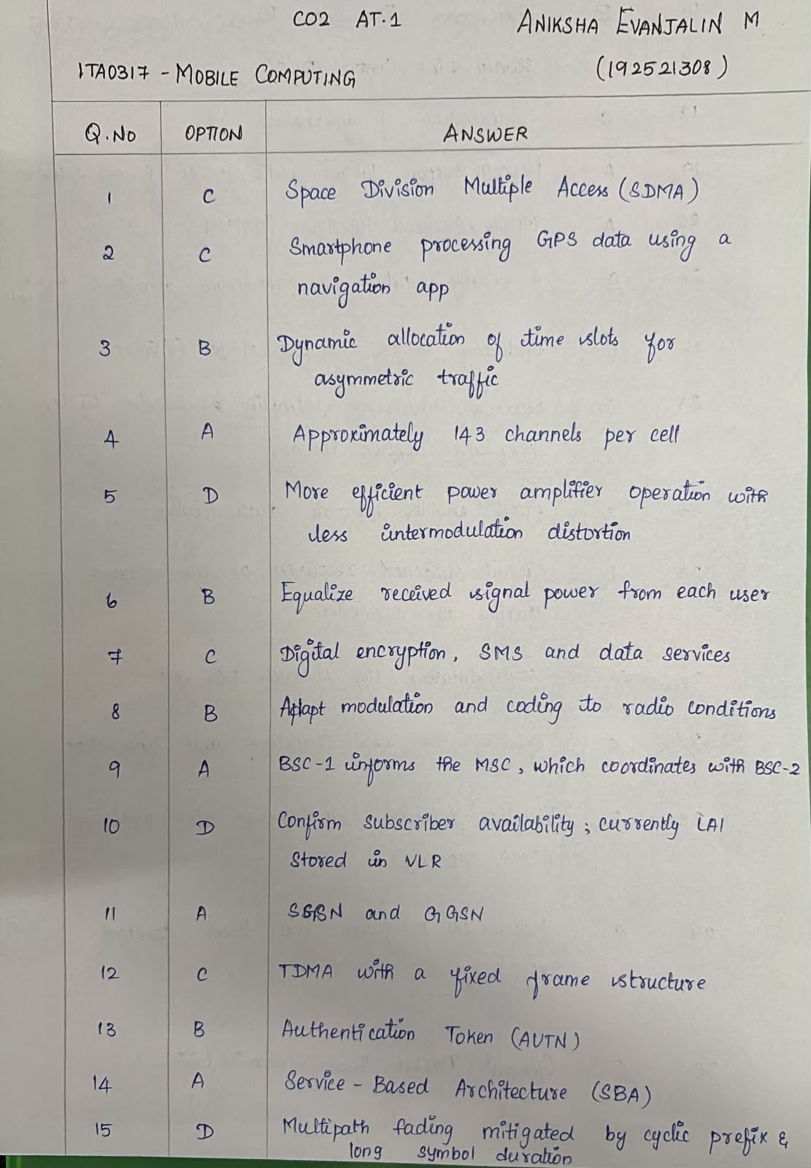
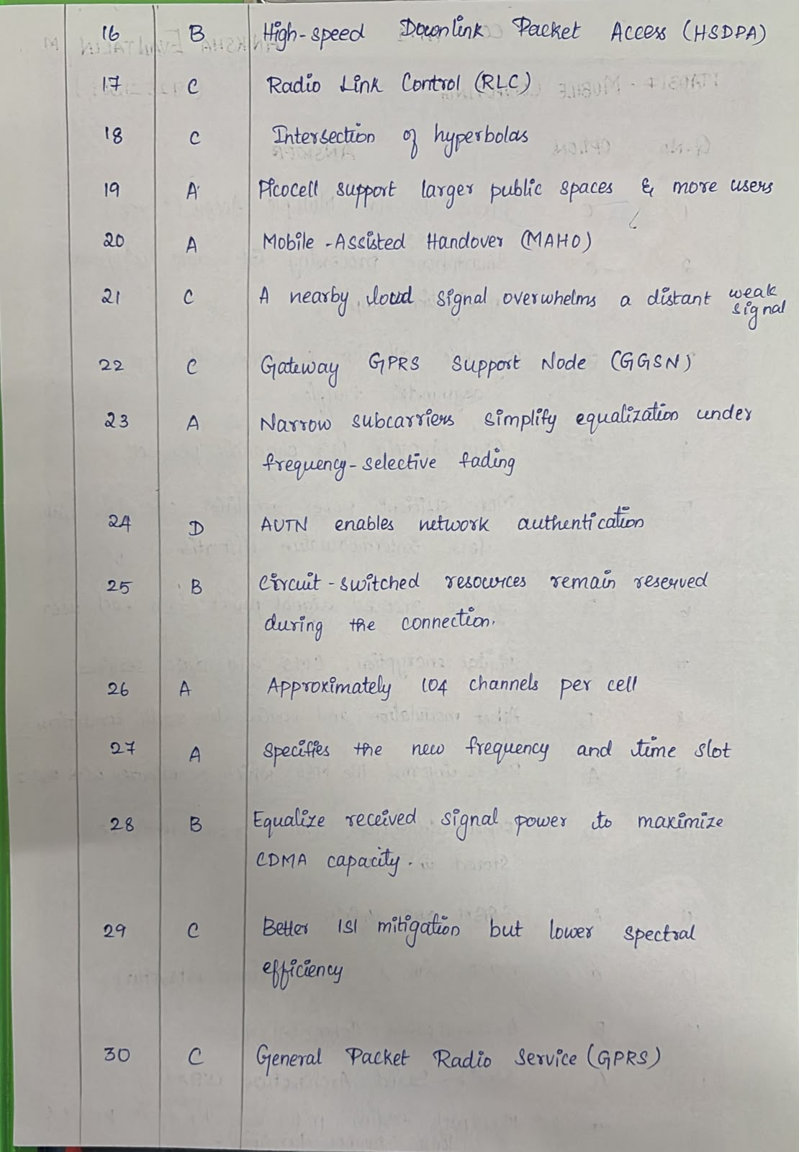
RUBRICS FOR CALCULATION:

Criteria | Weightage | Level 4 – Exemplary | Level 3 – Proficient | Level 2 – Developing | Level 1 – Beginning
Conceptual Understanding | 25% | Demonstrates excellent understanding and selects the correct answer | Demonstrates good understanding with minor gaps | Demonstrates basic understanding | Shows limited or incorrect understanding
Application of Concepts | 25% | Applies concepts accurately to identify the correct answer | Applies relevant concepts with minor errors | Applies basic concepts with some errors | Unable to apply relevant concepts
Analytical Thinking | 20% | Analyzes the question logically and identifies the best answer | Uses appropriate reasoning with minor gaps | Shows limited reasoning | Shows little or no analytical reasoning
Accuracy of Answer | 20% | Consistently selects correct answers | Makes few errors | Makes several errors | Frequently selects incorrect answers
Response & Completion | 10% | Answers all questions accurately within the allotted time | Completes most questions within time | Completes questions with some time difficulty | Unable to complete the questions within time

